Maaz Ullah Minhas

BSCS-5B   126437

Lab 07

Task 1:

Image slider or gallery using jQuery or jQuery Plugin



Task 2:

Image slider or gallery using jQuery or jQuery Plugin

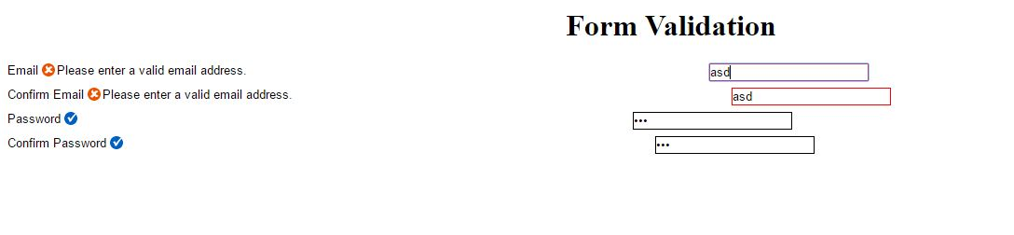

Task 3:

Add a circular progress bar that goes from 0% to 100% to a Web page

